Kafka Consumer Step

Objective

Kafka client that consumes records from a Kafka cluster.

It will transparently handle the failure of servers in the Kafka cluster and transparently adapt as partitions of data it fetches migrate within the cluster. This client also interacts with the server to allow groups of consumers to load balance consumption using consumer groups.

UI

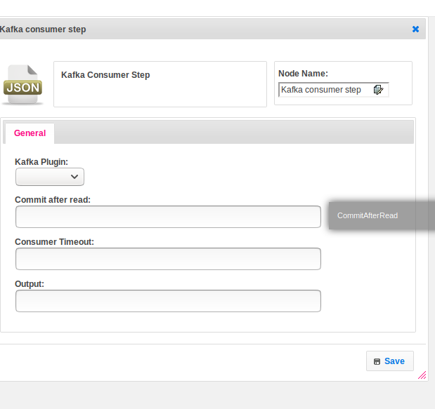

## Attributes

|  |  |
| --- | --- |
| **Attributes** | **Description** |
| **1. Kafka Plugin** | Name of the plugin. The plugin contains all the configuration information. To get more details please find the below Dependent Plugin block. |
| **2. Commit after read** | Provide boolean value. |
| **3. Consumer Timeout** | wait time in milliseconds |
| **4. Output** | Hold the user response. |

## Executor Description:

Pull the consumer records. Create the number of consumer records object. Checks consumer records equals null or not. If the count equals zero send the consumerPullStatus as false else get each record from consumer record based on topic.Finally, add the all records to record list. Put the map kay as topic and records as value.If commit_after_read is true commits the offset of record to the broker.

## Plugin Dependencies:

|  |  |
| --- | --- |
| **Attributes** | **Description** |
| **1. Plugin Configuration name** | Name of the plugin |
| **2. Broker** | A Kafka broker receives messages from producers and stores them on disk keyed by unique offset.  A Kafka broker allows consumers to fetch messages by topic, partition and offset.  Kafka brokers can create a Kafka cluster by sharing information between each other directly or indirectly using Zookeeper. |
| **3. Username** | Provide the username |
| **4. Password** | Provide the password |
| **5. Auto Commit Interval(MS)** | By default every 5 seconds a Consumer is going to commit its Offset to Kafka or every time data is fetched from the specified Topic it will commit the latest Offset. |
| **6. Session Timeout** | Provide time for the session. |

## Resource:

Find the below link to get more information

<https://kafka.apache.org/0100/javadoc/index.html?org/apache/kafka/clients/consumer/KafkaConsumer.html>